Holy and Great Week & Holy Pascha 2026

4 April – Lazarus Saturday Holy Baptism of our Catechumens followed 10:30 – 13:00
by the Divine Liturgy of St John Chrysostom*

5 April – Palm Sunday Matins & Blessing of the Palms 11:30 – 14:30
Divine Liturgy of St John Chrysostom*

Bridegroom Service (Ἀκολουθία τοῦ Νυμφίου) 16:00 – 17:30

6 April – Great Monday Bridegroom Service (Ἀκολουθία τοῦ Νυμφίου) 18:30 – 20:00

7 April – Great Tuesday Bridegroom Service (Ἀκολουθία τοῦ Νυμφίου) 18:30 – 20:00

9 April – Great Thursday Service of the Passion of Christ (12 Gospels) 18:30 – 22:30

10 April – Great Friday Vespers (Ἀποκαθήλωσις) 16:00 – 17:30
Taking down our Lord from the Cross

Service of the Lord’s Burial (Ἐπιτάφιος) 18:30 – 22:00

11 April – Great Saturday Paschal Vigil
Scripture reading. Midnight Office 19:00
Proclamation of the Resurrection leading to 20:00 – 23:00
Matins & Liturgy of HOLY PASCHA*

*Holy Communion is offered to all baptised and chrismated Orthodox Christians. Please note that Great Saturday is a fasting day. To receive communion in the night, fast from 2:00 PM onwards. While non-Orthodox Christian cannot receive Holy Communion they are welcome to take Blessed Bread (Antidoron) at the end of the service.

SECURITY IN THE EVENING

- Putting our safety and the security of the church first, we have been asked by our Anglican hosts to keep the front door of the church always closed during our evening services.
- To open, turn the handle anticlockwise. Please close the door behind you.
- ⁠It is a real privilege to have our Holy Week and Easter services in the evening.
- Thank you for supporting us and for helping to keep our church safe.
Christ is Risen!

Χριστὸς ἀνέστη! Христóсъ воскре́се! Hristos a înviat! ا الْمَسِيحُ قَامَ

We are a parish of the Ecumenical Patriarchate serving with the blessing of His Eminence Nikitas, Archbishop of Thyateira and Great Britain.

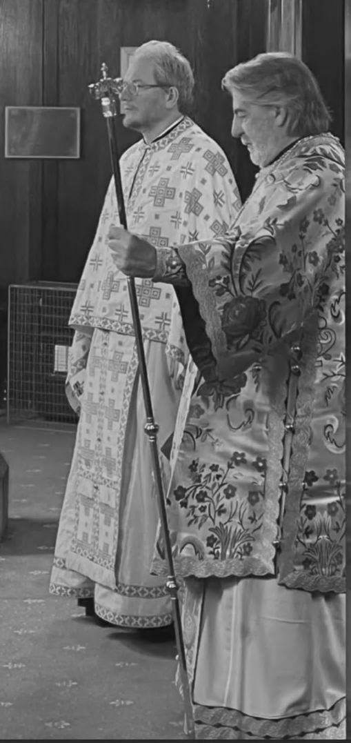
(Visit of H.E. Abp Nikitas in March 2024)

We are a registered charity but do not receive any governmental or other type of funding.

Your gift ensures our clergy are cared for
and our sacred space is maintained
with dignity and beauty.

Please consider making a regular donation to keep our Church open:

- you can do so at Church
- or online on GoodHub



www.goodhub.com/go/orthodox-middlesbrough

