Services for the Holy and Great Week & Holy Pascha (2025)

11 April – Last Friday in Lent 9th Hour & Baptismal Preparations 18:30-19:30

12 April – Lazarus Saturday Holy Baptism of our Catechumens followed 10:00-12:00
by the Divine Liturgy of St John Chrysostom

13 April – Palm Sunday Matins & Divine Liturgy 11:30-14:30

14 April – Great Monday Vespers & Presanctified Liturgy 18:30-20:00

15 April – Great Tuesday Bridegroom Service 18:30-20:00

16 April – Great Wednesday Service of Anointing 18:30-20:00

17 April – Great Thursday Divine Liturgy of St Basil 10:00-12noon

Matins with 12 Gospels 18:30-21:00

18 April – Great Friday Mattins with the Lamentations (Τα εγκώμια) 18:30-21:00

19 April – Great Saturday First Resurrection: St Basil’s Liturgy 10:00-12noon

Easter Vigil Matins & Divine Liturgy 21:00-midnight

20 April – Easter Sunday Vespers of Love. Gospels in Many Languages 18:30-20:00

SECURITY IN THE EVENING

- ⁠Putting our safety and the security of the church first, we have been asked by our Anglican hosts to keep the front door of the church locked during our evening services.
- ⁠We will keep the church door locked after letting people in at the start of the evening services. If you are late, please call the number posted on the front door to be let in.
- ⁠It is a privilege to have our Holy Week and Easter services in the evening. Thank you for your support and understanding.
Welcome to our Church!

We are a parish of the Ecumenical Patriarchate serving with the blessing of His Eminence Nikitas, Archbishop of Thyateira and Great Britain.

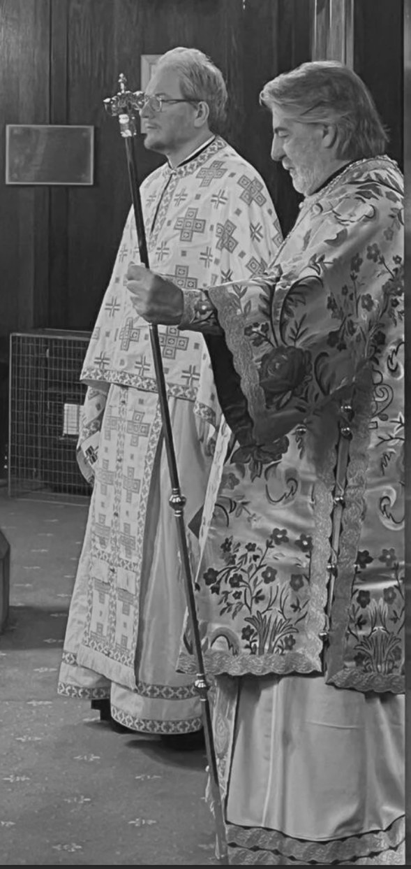
(Visit of H.E. Abp Nikitas in March 2024)

We are a registered charity (No: 1209900). Our church does not receive any governmental or other type of regular funding.
If you wish to support us with a donation,
- you can do so at church
- or online on GoodHub



www.goodhub.com/go/orthodox-middlesbrough

